COSC 3380 – Database Systems

Semester Term: Spring 2022

Team Members:

* Bryan Smith
* Daniel Amran
* Gleici Pereira
* Santiago Ignacio Hennig
* Seth Michael Leake

**Online Music Library**

**Library Database Concept:**

Coog Music is a web application built for UH musicians and students who want to post their songs and listen to music made by peer alumni. This application is a way to give a chance for local artists to reach a greater audience and help listeners support talented artists inside their own community.

**Data Requirements:**

The Online Music Library is divided into three user groups:

1. Simple users can search for songs, artists and albums, create and edit playlists, and control songs with pause, stop, or skip options.
2. Musician users have all Simple users’ properties plus the ability to upload their songs, assign them to albums, add their properties, and manage their profile as a musician.
3. Admin users have all Simple users’ capabilities and are responsible for administering the organization.

**Functional Requirements:**

* Users have an account according to their intended use: Simple, Musician, or Admin user. They need their first name, email and password for account creation and user authentication. All Users can search and listen to songs and create and edit their own playlists.
* The Simple user cannot upload songs. They can create their Simple user profile, make it public or not, and see other Musicians’ profiles.
* The Musician user can upload songs with their properties and assign them to albums or not. They have a public profile containing their songs and albums, and additional information about the artist.
* The Admin user is responsible for managing the Library Database and has all the types of permissions that exist in the system, which allow them to edit or delete other users’ profiles, personal settings, tracks, and albums.
* Music will have a minimum of one primary artist (User) and none or many featured artists, have a specified maximum length, and be assigned to none or many Albums.
* An Album will have a minimum of two songs and one or many creators.
* A Playlist can have one or many songs and must be managed only by the creator of the playlist.
* A User can have one set of Permissions, but a Permission type can be assigned to many Users.
* Permissions vary according to the user level. The Admin. user has all the set

**Conceptual Schema Diagram:**

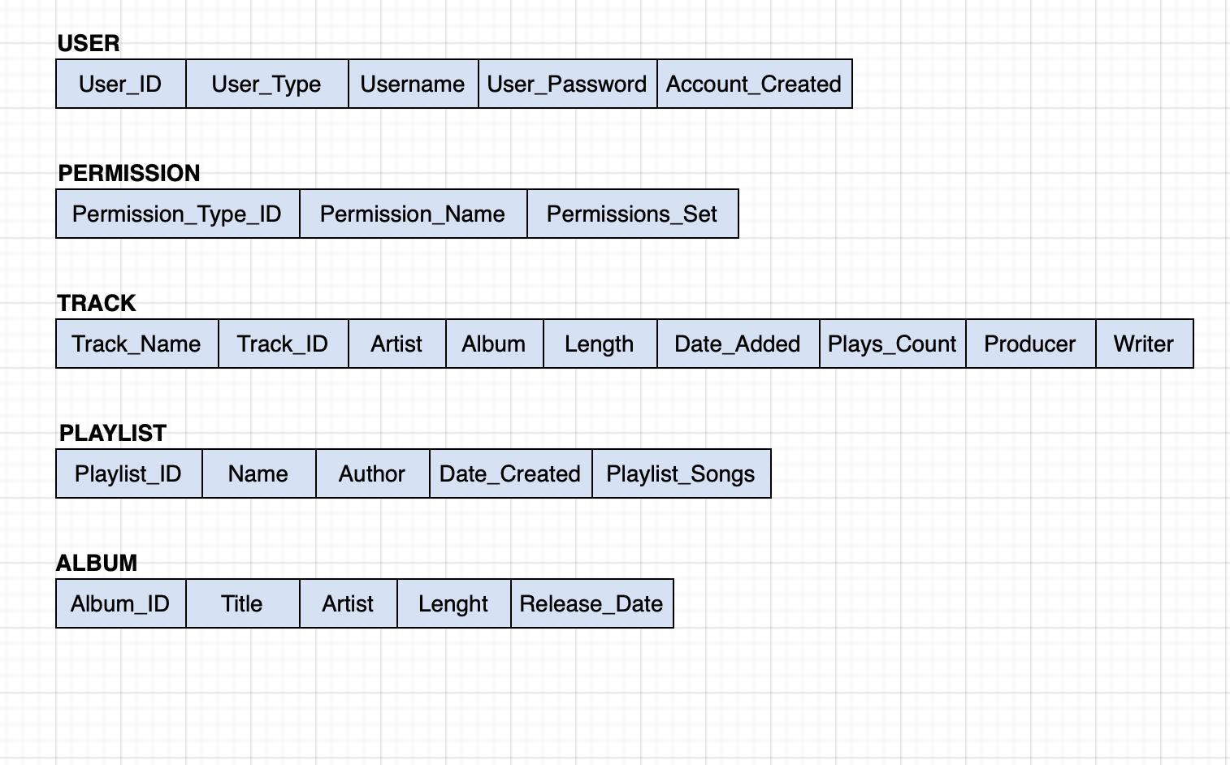

**Table Constraints**

**User Table**

USER_ID (int, primary key)

User_type; Musician, Listener, or Administrator (int)

Username (string, 32 char max)

Password (hash)

Date account created (date, YYYY-MM-DD)

**Track Table**

Song name (string 32 char max)

SONG_ID (int, primary key)

Album -> album table

Artist -> user table

Length (int, seconds)

Date added (date, YYYY-MM-DD)

Number of plays (integer)

Producer (string)

Writer (string)

**Playlist Table**

PLAYLIST_ID (int, primary key)

Playlist Name (string, 32 char max)

Songs in playlist (array) -> music table

Playlist creator -> user table

**Album Table**

ALBUM_ID (int, primary key)

Title (string, 32 char max)

Artist -> user table

Release Date (date, YYYY-MM-DD)

**Permission Table**

PERMISSION_TYPE (int, primary key)

Permission_Name (string)

Permissions_set (int)